Pedal Power: Bicycle Science
By Heidi Bee Roemer

Ben got a new bike and he's bursting with pride.
At the top of the hill, he is ready to ride.
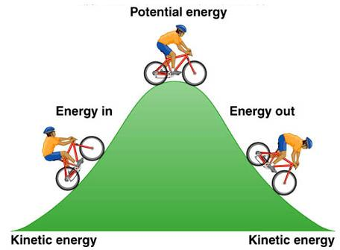
He fastens his helmet and sits on his seat—
Potential energy's at a high peak!

Pushing the peddles, Ben picks up speed.
Kinetic energy's also increased.
His bike gains momentum. Ben starts to coast.
Zooming downhill is what he loves the most!

Bicycle gears make Ben's wheels turn fast.
Look out! There's a tree that is blocking the path!
Ben has to stop! But will he be able?
Ben grips the brakes that pull on the cable...

…which causes the brake pads to clamp on the rim.
This creates friction to stop the wheel's spin!
Ben's proud of his bike and he's learned something new.
Biking is fun, and physics is, too!

CREDITS:
Video by Ryland Aeling
Copyright © 2024 by Heidi Bee Roemer

